CMP302 Gameplay Mechanics Development

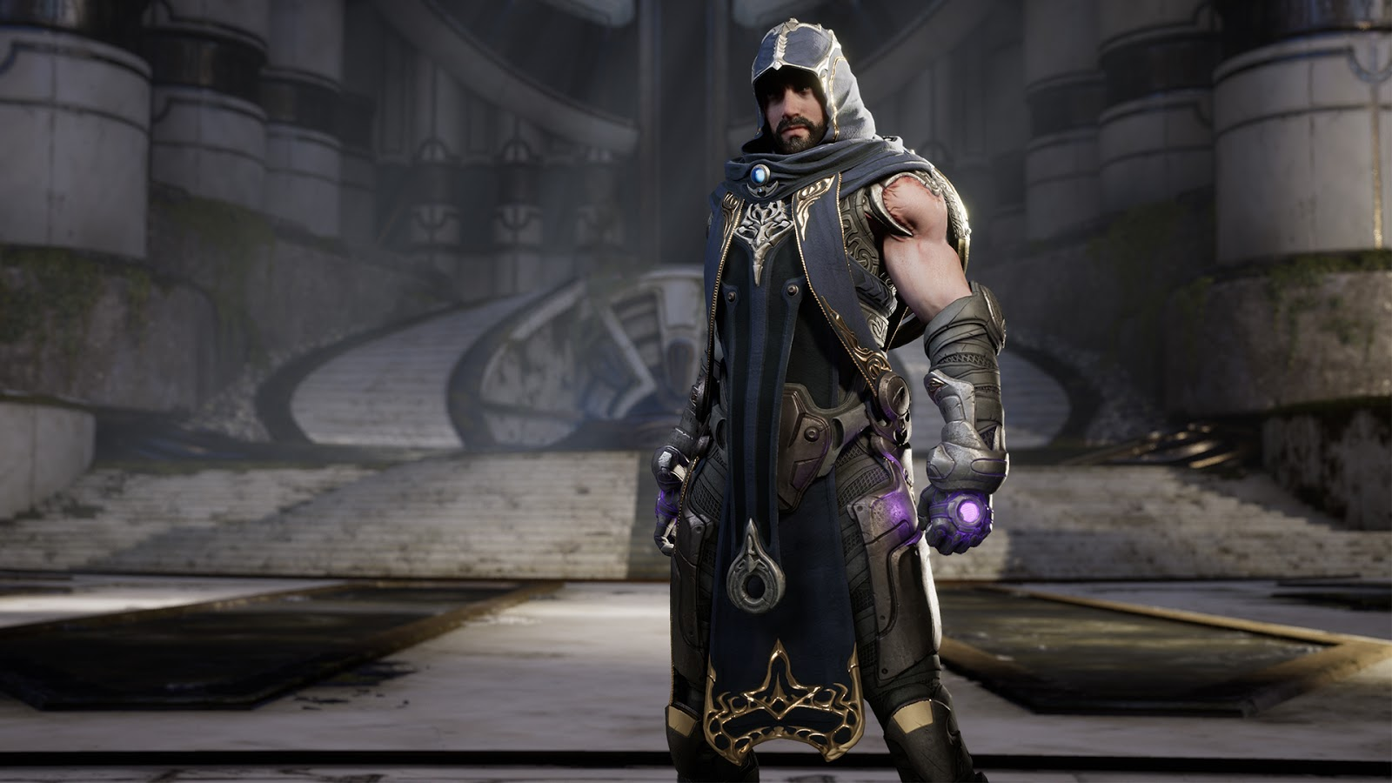

Earthbending Mechanic with expanded enemy AI Design Documentation

By Kyle Singer 2100888
Contents
Contents
Summary 3
Video Demonstration of Project 3
Project Requirements and Specification 4
Game Overview 4
Mechanic System and Rules 4
Developer Aims and Constraints 4
Project Function and Features 4
Overall: 4
Ability Selection: 5
Rock Manipulation: 5
Rock Throwing: 6
Rock Armour: 7
Summon Decoy: 8
Resources – Health and Mana: 9
Enemies – Artificial intelligence: 9
Created Classes and Objects 10
Project Methodology 10
Integration with Unreal Systems 11
Event System 11
Physics Engine 11
Animations 11
Collision System 11
Niagara System 11
User Interaction and Player Experience 11
Testing and QA 11
UML Diagram / technical Discussion 11
Development Process 11
Future Improvements 11
Analysis and Conclusion 11

Summary

This project aims to bring an aspect of the Avatar: The Last Airbender fantasy world, created by Michael Dante DiMartino and Bryan Konietzko in 2005 to life in a fun and interactive way. The main mechanic is the power of earthbending – which is manipulation of earth and rocks by the user, the project was inspired most by the fan game in the works by Elca Gaming ((415) Elca Gaming - YouTube), as well as the actual show which I grew up watching. Another recent inspiration is a new game on steam called RumbleVR – which is an earthbending battle game, with two players competing against each other in an arena. The mechanic and system are made up of several key components:

- 3 different earthbending abilities with different effects and uses.:
  - Lift a rock from the ground and hold it in place for a few seconds before it falls to the ground, with the ability to throw it wherever you are looking.
  - Summon rocks from the ground to stick to the character like armour, increasing damage resistance for a short time.
  - Spawn a clone of the player that runs in a random direction to confuse enemies.

- Health and mana system implemented in C++:
  - Gives the player a set health, that can be regained by defeating enemies.
  - A mana system which makes each action cost a set amount of “energy” to use, increasing player involvement as they must plan their actions or risk not being able defend themselves.
  - Player mana regenerates over time, at a rate of 5 every second.
- Enemies with custom coded Artificial Intelligence
  - Custom behaviour tree with custom tasks coded in C++ and implemented in engine.
  - Enemies have a vision cone to detect the player character.

Video Demonstration of Project

The video demonstration for my mechanic can be found here:

Project Requirements and Specification

Game Overview
The game is a fantasy, action-adventure game set in the world of Avatar: The Last Airbender, you play as an earthbender defending his home against incoming enemies. The player moves with the WASD keys, can jump with the spacebar and can look around with mouse movements, the perspective starts out in first person but can be changed by pressing the V key – moving to a third person view. Pressing 1,2 and 3 allows the user to switch between abilities, which are then activated via left mouse click. When using ability 1 (the rock lift and throw), you can throw the rock to the centre of your vision by right clicking. Elements of strategy are also incorporated into the gameplay, with a mana system to limit the players abilities, making them think before they act or risk dying to lack of preparation effectively creating a slight skill curve in the game.

Mechanic System and Rules

Developer Aims and Constraints
The main goal of the project was to create a fun and action-packed earthbending mechanic that gives the player a range of abilities to use alongside a built-in mana system to encourage strategy and planning. Accurate physics was a must from the beginning, using Unreal Engines physics system to help the player “feel” the weight of each rock. Shown subtly through the rock rise, where the player gets feedback of the rock falling slightly and rising again to convey a sense of weight. The rock throw conveys this feeling as well as the player will soon discover that the size of the rock, they have will impact their overall strategy due to larger rocks not travelling as fast or as far as smaller rocks.
The main constraint during development was a commitment to ensure as close to 100% C++ implementation as possible. While some aspects of the project (such as animation blueprints) are impossible to create in C++, anything that was capable of being developed in classes, was.

Project Function and Features
During the planning process of development, the developer had come up with a series of rules and regulations for what the project will and won’t do:

Overall:
The User must be able to easily and proficiently control each ability, executing each one at any time with the ability to switch abilities depending on the current situation. The user must not be able to exploit abilities to gain an unfair or unintended advantage, such as stacking armour on the “Rock Armour” ability or infinite casting of “rock throw” to constantly throw rocks at enemies.

Ability Selection:
Description:
Allows the player to use the left click for every ability, by pressing 1-3 on the keyboard the player is able to select a different ability to use. If a noncorresponding number is selected the previous number will stay.
Requirements:
N/a
Interactions:
interacts within the earthbender class, as every ability is managed and called and activated there.
User Guideline:
The User must:
- be able to use the keys on the keyboard to seamlessly switch between different abilities depending on the number pressed.
- Be able to use all abilities with left click and receive a different action based on the selected key.
The user must not:
- be able to select a number that does not have an ability assigned to it, instead using the previous number.
- Be able to exploit the system by rapidly switching between abilities.
Developer Guideline:
The Developer must:
- be able to expand the existing system available easily and effectively to quickly add new abilities to the project while maintaining a consistent coherence between new and old inputs and actions.

Rock Manipulation:
Description:
The player ability bound to the 1 key. When activated a rock rises up from the ground and hovers in place at the players eye level, shielding them from any attacks from the front while obscuring their vision. After a set time the player can’t hold onto the rock anymore and it falls to the ground. Ability is activated via left click on the mouse, providing the 1 key has been pressed to select the correct ability.
Requirements:
- On left click ability 1 must be selected.
- Player mana must be more than 25.
- Rock class must be valid.
Interactions:
The rock spawned will not interact with anything in the world while it is rising from the ground, will block damage from the front while floating if an enemy collides with it.
User Guideline:
The user must:
- be able to left click and see a rock rise up from the ground and float in place for a set period of time before falling to the ground again.
- Be able to strategize with the rocks, opting to use the ability for offensive and defensive options.
- Have a variety of options of rocks to use - different sizes, shapes and rotations so that no two rocks are the same.
- Be able to visually see the weight of rocks during manipulation to convey the feeling of mass.
The user must not:
- be able to take damage from their own rock rising from the ground.
Developer Guideline:
The developer must:
- be able to easily modify the rocks for balance purposes, with variables accessible both in engine and in code.
- Be able to add new rock types with unique functionality.
- Also ensure that a system is in place to prevent spamming of rocks by the user.
- The rock itself must not interact with the ground during the rising process to prevent instant destruction.
- The developers must not make changes that would unfairly impact players and the core mechanic of how the rock is manipulated without proper testing.

Rock Throwing:
Description:
With a rock in the “active” state of floating in the air, right click can be pressed to push the rock forward towards the player crosshair with an impulse calculated based on the rocks scale factor, physics is enabled at this point so that the rock begins to fall as soon as it is fired forward. This is used as an offensive attack by the player.
Requirements:
- Rock object must be valid before the rock can fire.
- Player mana must be more than 10.
Interactions:
Upon colliding with a player, enemy or any aspect of the world the rock will destroy itself, exploding into small rocks that can interact with the environment before disappearing.
If an enemy is collided with, they lose 50 health and are stunned for 1 second.

User Guideline:
The user must:
- be able to fire an active rock at their cursor point, alongside this different rock sizes must have different travel speeds / distances based on their mass.
- Feel the difference between different sized rocks and change strategy accordingly.
- Feel that the aiming is intuitive and rocks accurately land where the user targets.
The user must not:
- have accurate aim if they are moving around when firing a rock, this would decrease accuracy and must be shown as such.
- Be able to spam rock throws for an unfair advantage.
Developer Guideline:
The developer must:
- ensure that rock throws are accurate and land according to player expectations, with some inaccuracy added on with movement.
The developer must not:
- Change impulse calculations without proper testing and regard for realism for player satisfaction.
- Create incorrect physics implementations that lead to unstable rock movements, which could create an unfair advantage for players.

Rock Armour:
Description:
The player ability bound to the 1 key. When activated the player is surrounded in rocks forming a suit of armour, reducing player damage taken by 50% for 8 seconds. Over the duration of the ability, you can see small rocks falling from the armour to show the temporary aspect of the protection. The ability is activated with left click providing the 2 key has been pressed to activate the ability.
Requirements:
- Player mana must be more than 100.
Interactions:
Any damage taken by the player during the ability duration will be reduced by 50%, meaning if the player were to lose 100 health, they would now lose only 50.
KYLE MAYBE MAKE THE HEALTH GO DOWN OVER 3 SECONDS.
User Guideline:
The user must:
- be able to activate the ability and have a visual indicator of their armour, via HUD or visual cues (attaching rocks to the model).
- Know the time limit for the ability to encourage planning and strategy.
- Be mindful of the resource cost of using this ability to effectively implement it into their battle strategy.
The user must not:
- be able to exploit the ability to gain indefinite immunity to damage by enemies nor indefinite damage resistance.
- The user must not be able to solely use the armour to complete puzzles and defeat enemies, this can be achieved with resource management systems.

Developer Guideline:
The developer must:
- ensure that players cannot rely solely on the armour and use no other abilities, balancing features such as tweaking mana costs should be considered and tested accordingly.
- Implement the rock armour damage resistance seamlessly into the combat system to ensure players receive reduced damage while the ability is active.
- Ensure that the use of the ability does not impact or exploit any AI vulnerabilities.
The developer must not:
- implement any visual changes that confuse the effectiveness of the armour – the armour covers the entire body and any area hit has damage reduction.
- Change the balance of resource cost for the ability without testing, so it is not too hard or easy for players.

Summon Decoy:
Description:
The player ability bound to the 3 key. When activated a replica of the player character spawns in around the player and runs around, distracting the enemy, it can move around randomly for 6 seconds until it disappears. The ability is activated with left mouse button providing that the 3 key has been pressed.
Requirements:
- Player mana must be more than 75.
- Clone object must be valid.
- World object must be valid.
Interactions:
The decoys -
User Guideline:
The user must:
- be able to use the clone to strategically outmanoeuvre enemies or escape unfavourable combat situations.
- Ability to control clone movement somehow (either by clones moving to random positions or moving to player cursor).
The user must not:
- Be able to exploit combat AI with the clone for an easier combat situation.
- The user should not be able to spam the ability to create many clones to confuse the AI.
Developer Guideline:
The developer must:
- Ensure that the clone has a subtle visual or auditory cue to show it is not the actual player, either rock particles in places or sand sounds from footsteps.
- The ability must be balanced in terms of resource costs to ensure a fair playing experience.

Resources – Health and Mana:
Description:
The resource bars have been implemented to add a skill curve to the game while also adding an in-game currency that must be managed by the player to use abilities.
Requirements:
Every 2 seconds the player gains 10 mana, being capped at 250 mana.
Interactions:
the resources are mainly used in the player class and are initially set in the basecharacter class – which both earthbender and enemy inherit variables and meshes from.
User Guideline:
The user must:
- Have an on-screen representation of their health and mana values so they can visually see the values.
- Have a passive mana gain as well as mana and health gain for enemies defeated in combat.
- Manage their mana resource to use abilities.
- Strategically manage their health via blocking and defeating enemies

The user most not:
- Be able to exploit the mana system to spam abilities.
- Be able to overlook the mana system or exploit it in any way as its implementation is for gameplay balance.
- Completely rely on other sources of healing, instead focussing on defeating enemies to gain back lost health.
Developer Guideline:
The developer must:
- Can customise and modify the existing system to implement a new resource easily / extend to another class.
- Be able to easily modify the visual health and mana representations.
The developer must not:
- Implement any abilities that reduce the effectiveness of the system.
- Make changes that impact the difficulty of gaining health or mana in an unfair way.
- Implement any changes that would confuse the visual appearance of the health and mana resource.

Enemies – Artificial intelligence:
Description:
The enemies in the scene follow a custom created behaviour tree with coded tasks and vision, they hunt the player down and battle with them. They disappear upon defeat and restore the players health and mana.
Requirements:

Interactions:
Enemies can interact with the world via navigation mesh, which maps out where they can and can’t move. The behaviour tree iterates through and based on certain criteria will initiate certain behaviours. For example, if the player is not in vision, then move to a random location and search again.
User Guideline:
The user must:
- Feel a sense of challenge from combat with the enemies.
The user must not:
- Be able to exploit any weakness or flaw discovered in the AI.
Developer Guideline:
The developer must:
- Be able to customise the AI behaviour and tweak any values easily and quickly to change behaviour on the fly for balance.
- Develop an AI that feels like more than a robot reacting to play inputs (patrolling and use of peripherals such as vision and hearing).
- Implement a feedback to alert the player to an AI spotting them.
The developer must not:
- Develop an “unfair” enemy AI that always knows what a player is doing or where they are.
- Avoid developing a behaviour tree that can lead to an AI becoming too predictable.

Project Methodology
Ability Selection:
When the project expanded to incorporate 3 different abilities the Ability selection was implemented to allow each ability to be bound to the same left mouse press. Input events are set up for keys 1-3 for each ability. These input events are linked to actions in the unreal engine settings called action mappings.
The earthbender class sets a value called “currentpower” to whatever number was pressed, upon left mouse click there is a switch statement that calls a particular ability based on the number that was last pressed by the player. The ability selection was expanded to include UI elements, with the name of whatever ability and corresponding image being set in game depending on active ability
Rock Manipulation:
Rock manipulation makes use of a timeline created by the developer in C++, this timeline uses a floatcurve created in engine and passed through with FObjectFinder. The curve rises quickly and then over time lowers and rises until the rock drops. Physics and collisions are disabled during the process and enabled at the very end via function. In MyEarthbender the rock player forward vector and location are saved as variables, with the forward vector being multiplied by a random number between 200 and 400. The “spawnLocation” variable is made up of the player position in the world plus the forward vector – z axis of this is always set to 0 before spawning so the rock can rise up. The rock is assigned to an object of the “MyRock” class called HeldRock and spawned into the world. This object then calls the timeline function to smoothly rise from the ground to the eye height of the model.
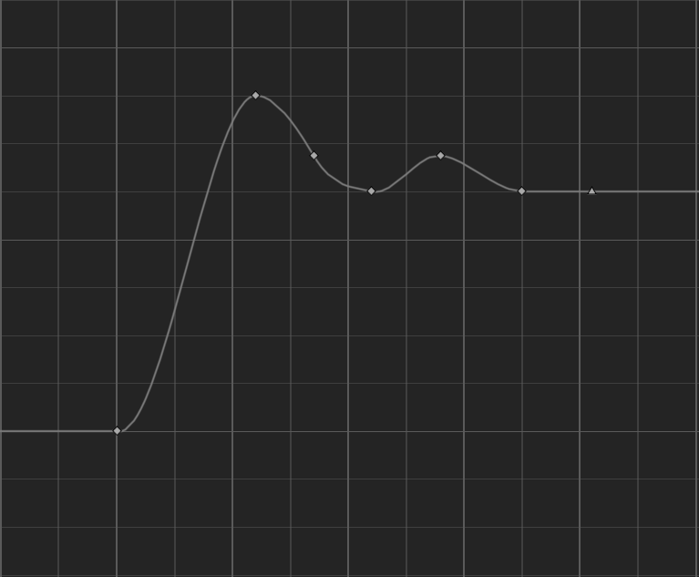
Figure 1: Float curve created for rock rising ability.
The rock class randomly assigns each rock a mesh from an array of meshes, a random scale as well as a random rotation to make every single rock look unique. An initial lifespan is also set to despawn the rock after a set amount of time.
Rock Throwing:
If a valid rock object is available, the timeline is stopped if it hasn’t completed, and the direction is set to where the player is aiming by getting the controlrotation. The “MyRock” class has a function called “FireInDirection” which is called with the “throwDirection” gathered from the player view and an animation is played.
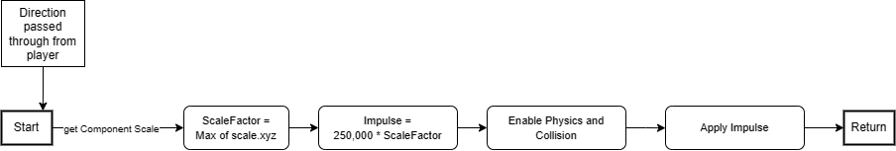
Figure 2: Diagram to show how the rock is fired and the steps behind it. Created by developer. From Draw.io
The “FireInDirection” function calculates an impulse scale based on the scale of the rock, returning the highest of the X,Y and Z scale values and multiplying that value by 250,000. Physics is enabled and then the impulse is multiplied by the throw direction from player and then applied to the rock object.
Rock Armour:
Upon activation there is a check to ensure the player has enough mana to use the ability, then the custom “UActorComponent” called “MyRockArmour” is set to activate in “MyEarthbender” and the mana cost is removed.
In the “MyRockArmour” tick function there is a check to see if active has been set to true, once it has been set the Niagara particle effects are activated and the timer is started by adding “DeltaTime” to a timer variable until 8 seconds has passed, where the timer is set to 0 and active is set to false. There is a secondary Boolean called “active” which is used to ensure the Niagara system only activates once instead of every frame for the next 8 seconds.
Summon Decoy:
After an initial check to ensure a valid class object is detected and a check that world is valid a random spawn angle is calculated for the clone, this sets each clone to face a different direction on spawn.
The process of spawning the clone is similar to the rock spawn, where the player rotation and position are saved as variables and used to calculate a spawn point – only difference being an offset variable which uses the random spawn angle to create a circle around the player in which the clone will spawn. The spawn point is then multiplied by a random number between 200 and 500 so the clones spawn at a random distance away from the player, in a circle determined by the random angle they face. A clone object called “clone” is created and initialised which is then spawned into the world.
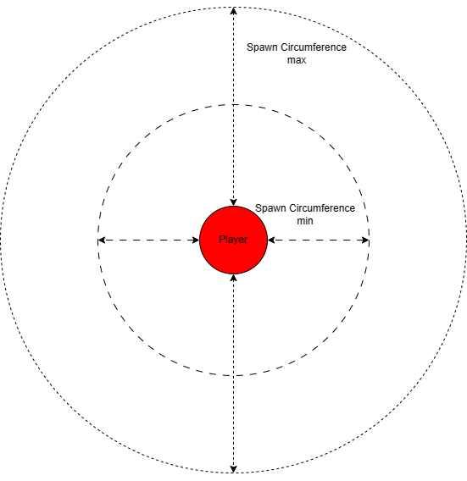
Figure 3: Diagram showing how the clone spawn location is determined.

The clone class handles everything else, all meshes and animations are assigned in the constructor or “BeginPlay” before the clone is possessed by the base AIController and sent to a random position in the navigable zone.
Resources – Health and Mana:
Health and mana values are assigned in the player and enemy class while being stored in BaseCharacter respectively. Health is removed when a player takes damage, while mana is removed every time an ability is used. Mana can be passively regained every 2 seconds by adding the “DeltaTime” value every tick of game time, adding the passive mana value then clamping the max mana value for player which is passed through from the player class. Another function handles gaining and losing resources from other means, this passes through a number which can be positive or negative. Depending on the sign passed through depends on if the resources is added to or removed from.
The player can lose health from taking damage from enemies and gain it from defeating enemies. Mana is lost through ability use and gained from defeating enemies and passively at a rate of 5 mana every 1 second.
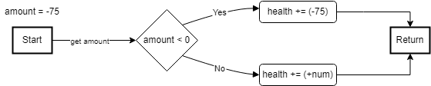
Figure 4: Diagram of how the health change system works. Created by developer. From Draw.io
HUD and UI
The HUD is very simple, including a health and mana bar alongside the name of the selected ability at the bottom right with a picture above. The progress bar widgets increase and decrease as health and mana change while the text and image change based on the currently selected ability.
Enemies – Artificial Intelligence:
The enemies are governed by a custom created behaviour tree with custom C++ classes for tasks and services, the enemies inherit from basecharacter and will patrol the area they spawn in, moving to a random location within 1500 units while using their vision cone to search for the player. Upon seeing a stimulus the tree determines if the stimulus is a player or a clone and picks a branch appropriately. If the clone is in vision the enemy automatically chases and prefers that over the player character. Upon damaging the enemy they are stunned and play a hurt animation, then upon death they ragdoll and the player is restored 100 mana.
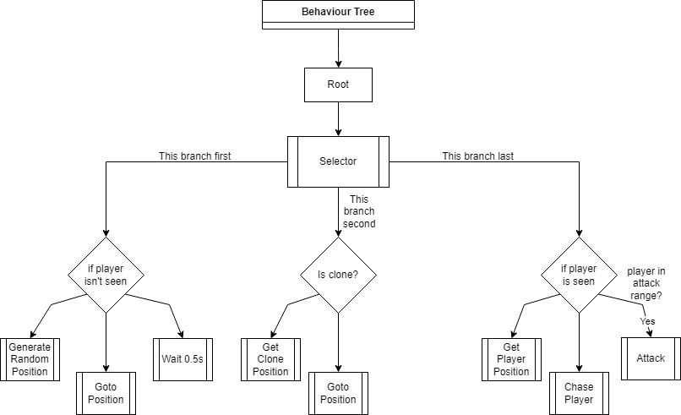
Figure 5: Diagram showing plan for how the developed set up the behaviour Tree. Created by developer. From Draw.io

Integration with Unreal Systems
During the development process it was a priority to ensure seamless integration to unreal engines systems to allow utilisation of key functionalities for the project in the C++ classes, while further increasing polish.

Event System
The Event system was highly utilised for parts of the project, all input was coded in the C++ class with use of input events which are set in engine and call the specified events in the project.
Delegates were used for functions in the project to pass through custom variable amounts to input event functions as well as for enemy AI implementation of peripherals.
Collision events were used for interactions between entities which is discussed shortly.

Physics Engine
The entire project makes use of the default Unreal Engine physics system as this is the industry standard for many games created in engine and allowed me to simulate real world physics on my rocks and characters.

Animations
In the project I made use of the Epic Games Paragon Gideon animation blueprint provided, this plays movement animations based on acceleration. The animations are blended so you can move and play the attack animation, custom animation montages were created in development for certain functions like taking damage and dying, these are called in C++ whenever required. The animation blueprint itself was modified slightly to allow for extra animations to play.

Collision System
Collisions are handled in engine with the built-in functionality, with response functions coded in the individual classes with statements depending on the object being interacted with, if the rock collides with anything it will play its collision response.

Niagara System
The Niagara particle effect system is used for extra polish and visual fidelity. Spawning with certain actions and as a collision response for rock destruction.

User Interaction and Player Experience
During Development a primary concern was user interaction and the overall player experience, the project was shifted to have an emphasis on allowing the player to immerse themselves into the role of an earthbender by trying to use the Unreal Engine physics and other techniques to make the players “feel” the weight of their actions and abilities. I also wanted to try and foster a sense of emergent gameplay, where a players actions could lead to an unexpected outcome for them which could lead to further creativity in game.
A sense of player agency was added to the project, by allowing players multiple abilities to use at any time allows for a greater sense of control and a more diverging gameplay story for each player, as each different choice could impact the game outcome. To increase player immersion the rocks don’t just disappear on collision and instead makes use of the Niagara particle effects system to create visual stimulus to the player that they can no longer use that rock and must bring another up from the ground. Each rock brought from the ground also has a different size, shape, rotation and position away from the player which makes every rock look unique.
The User interface while basic gets across all required information to the player, with indicators for health and mana levels, as well as which spell is selected at that time.

UML Diagram / Technical Discussion

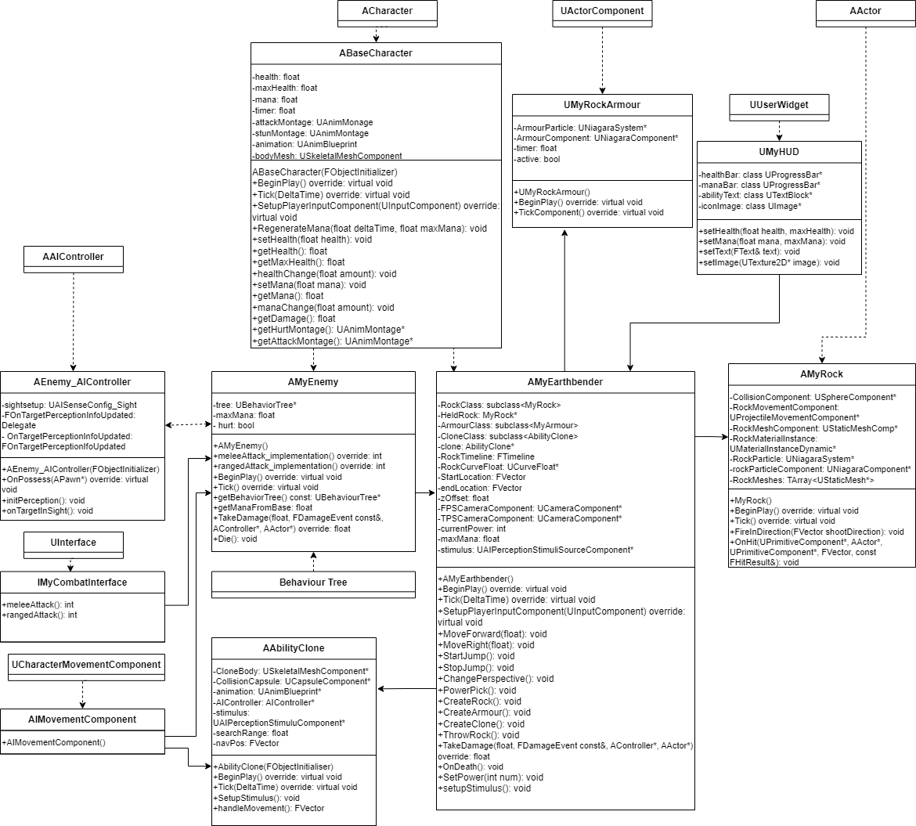
Figure 6: UML Diagram of CMP302 Earthbending project, created by developer. From Draw.io
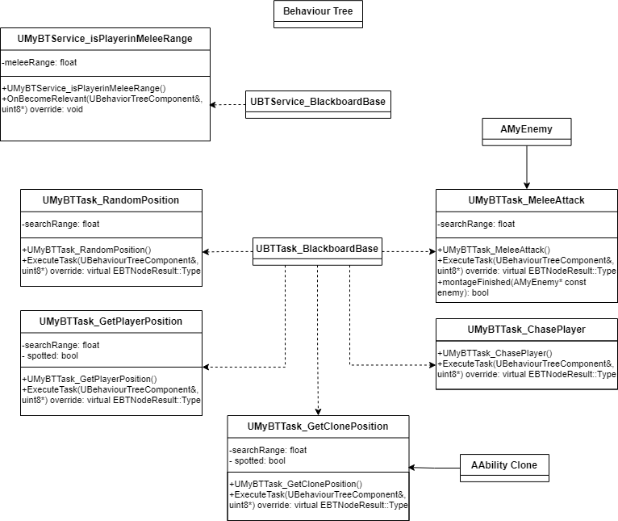
Figure7: UML Diagram of CMP302 Earthbending project behaviour tree tasks. Created by Developer. From Draw.io

Beginning Steps – Camera Setup & Input:
The first stage of development was the creation of an Earthbender class that would be the main bones of the project. The first feature implemented was a first and third-person camera with the ability to switch perspectives at any time, accomplished by an if statement which swapped a Boolean variable before checking the new value of the variable and setting the camera accordingly. Below is a creative diagram used during development:
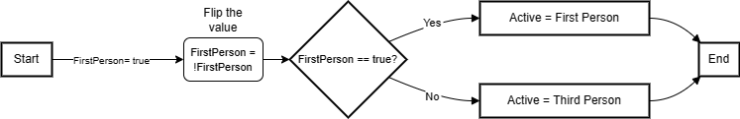
Figure 8: Diagram of the process behind camera switching perspectives. Created by Developer. From Draw.io
Due to the approach of attempting to do as much in C++ as possible the earthbender class has all player controls bound to input events, these are set in the engine settings and a function is bound to each event respectively, for example the W key is bound to “moveForward” in engine, in the class when that event is called it plays the bound function “&AMyEarthbender::MoveForward”. To accomplish this, you need to use a function inherited from “ABaseCharacter” which itself inherits from Unreal Engines “ACharacter” class, this allows you to bind your own functions to input events, using the players input component.
Rock Rise Mechanic:
The first mechanic in the development process was the rock rise and throw ability, this was initially the sole mechanic of the project. The rock makes use of a timeline, created in C++ to have the rock rise to the correct position over a set period. The rise is determined by lerping the start position and end position by the current value of the float curve – which was created in engine by the developer, the curve starts with a steep rise to show the rock coming from the ground and gradually lowers and rises until the end:
To spawn the rock itself the player must have enough mana which is checked in an if statement, as well as another check to ensure the subclass of rock is valid. The player world location, rotation and forward values are assigned to variables, with the forward vector being multiplied by a random range between 200 and 400 to randomly set a position between the rock and player character. The spawnlocation variable is made up of the position and forward added together, with the Z value being set to 0 so the rock is always spawned on ground level. An object of the “MyRock” class is created and assigned to the new spawned actor in world.
Upon spawning the start and end value of the rock are set according to the rock actor current location, with the z being set to the offset variable which is made up of the “BaseEyeHeight” value from the Pawn class with an additional added on for the model size. The timeline then begins and the mana is deducted from the player. In the constructor for the rock, all physics and collisions are disabled while the rock rises from the ground to prevent instant destruction, this is then reapplied later when required.
When the rock object is first initialised, the constructor is called which adds 3 meshes into an array which are from the “Stylized Provencal pack”. A number is randomly generated, with the number corresponding to the position of a rock in the array – that mesh will be set as the used mesh after a check to ensure that the number is a valid index number. The material of the rock is set based on a material from the “Stylized Provencal pack”, then a rotation and scale value (rotation between 0 and 360 degrees and scale between 2 and 2.5 respectively) are randomly set before attachment to the root component, which is a collision component sphere.
Rock Throw:
For the rock throw part of the mechanic there is a check that the rock object is valid before the players view rotation is stored in a variable and pass through to the “MyRock” class via the “FireInDirection” function. The attack animation montage is then called in “MyEarthbender”.
In the “MyRock” class the force or impulse of the rock is calculated using the scale value of the rock, the value is determined by the higher of the three axis scale values. This scale value is then multiplied by 250,000 to determine the overall impulse strength. The impulse is applied to the rock alongside the player direction, passed in from “MyEarthbender”:

Rock Armour Mechanic:
The rock armour is a UActorComponent attached to the earthbender class. When the ability is activated the component is set to active which spawns the rocks on the model. In the armour class the tick function is always checking for activation to be true and once it is the root component from player is obtained through use of the GetOwner() function. If the OwnerComponent is valid the playercontroller is gained and used to check if there is a valid player alongside a custom Boolean to check the Niagara isn’t already active. Niagara is activated and bound to the owner root component and the custom Boolean is set to true to prevent Niagara spawning every frame, the timer float then adds the DeltaTime value on every tick until 8 seconds have passed which sets active to false and resets the timer. When the player is experiencing a health loss with the armour on the game checks if the rock armour component is set to active and will half the damage being taken.
Ability Clone Mechanic:
The clone mechanic summons a character with the same model as the player character which moves around the world using a navmesh generated in engine. It is spawned very similarly to the rocks above, with an initial check that the subclass is valid as well as world before anything happens. A random spawn angle is calculated between 0 and 360 which firstly is used to set the direction the clone faces on spawn in. The random spawn angle is the added to an FVector called offset to make a circle around the player in which the clone will spawn, this circle is added to the actor location as well as multiplied by a random float between 200 and 500 to increase the circle distance from the player but a random amount.
The constructor from the clone class is the same as the player class as everything is the same. The clones have an initial lifespan which is from the Unreal AActor class, this is set to 10 seconds and when the time is up they despawn. Upon spawning in the “BeginPlay” function, the clone is possessed by the AI Controller and a random position is set for the clone to move to. Using the AIController function “MoveToLocation” the character gets a random position from a function which returns an FVector based on finding a random point in the navmesh using the actor start position, the navmesh and the range around the clone. The Z position is set to the capsule height and the location in the navmesh is saved as an FVector for use in the tick function.
In the tick function there is a check using FVector::Dist to check if the actor location is equal to the random position assigned within a threshold of 100, if true then a new order is issued and a new random position is set.
Resources – Health and Mana:
The resources were added to the project after the abilities were completed. They are variables found in “ABaseCharacter” class from which enemy and earthbender inherit from, mana is used whenever abilities are cast with a different cost for each ability. Health is only lost when the player takes damage from an enemy or their own rock throws. Mana has a regeneration mechanic where man is added at a set time interval. A float timer is used in the “rengenerateMana” function called in the Earthbender class tick function which adds the “DeltaTime” variable every frame until the value is equal to 1.0f or 1 second. If true then 5 mana is added to the value of the class which called the value. The mana value passed through is used in an unreal FMath clamp function to ensure the player cannot go over the maximum mana amount.
There are two functions responsible for adding and removing mana, minus the passive mana gain, these are called “healthChange” and “manaChange”, these receive a value to add or remove from their respective resource and depending on the sign of the value depends on if the total is increased or decreased. If a negative number is passed through the if statement knows the resource should be reduced.
Enemies – Artificial Intelligence:
The enemy class comes from “BaseCharacter” alongside the earthbender class. The constructor initialises everything required from meshes to the custom tree and AI Controller. The behaviour tree governs most of the enemy actions and movement however through the use of a custom interface for combat the attack implementation is called from enemy as well as the TakeDamage function – responsible for any collision response from the enemy. The die function is also called in enemy which simulates ragdoll physics upon health loss. When an enemy is hit by a rock controller input is disabled and a hurt animation plays, when the animation is over the enemy begins moving again. Upon death a function is called which ragdolls the enemy for 10 seconds and sets a lifespan to despawn. The player will also receive 100 mana back from the enemy upon ragdoll. The player reference is passed through with the TakeDamage function and cast to a new variable.
Behaviour Tree Tasks:
The behaviour tree is set up in engine while the tasks are created via C++. The selector decides between which branch to go down based on if the player has been seen or not as well as if the clone has been seen, with the enemy patrolling if the player hasn’t been spotted yet.
The first task created finds a random position within a range of 1500 units of the enemy location and sets it as the new moveto position. The engine moveto function is then used to move from A to B. The function gets the current enemy pawn from the custom AIController and gets a start position from this pawn. The navmesh if obtained from the world and a random point in the radius of 1500 units is gained, the value of the random point is saved as a blackboard variable called TargetLocation.
The second function is used whenever the enemy detects a visual stimulus from the player entering their vision cone. This function works similarly to the other where the player is stored as a variable temporarily to gain their position in world. If the enemy can see the player in their eyeline they will go straight to the player location while if the player manages to lose enemy vision they will go to a random point within 150 units of the player location at the moment of vision loss. This new position is saved in the blackboard variable TargetLocation.
The next set of Behaviour Tree services cast the enemy and player to variables to check if the enemy is within a certain range of the player while chasing. The Boolean “is in melee range” is set true or false depending on if the enemy distance from the player is less than the set range value of 90 units. When the Boolean is true the attack task is called.
The attack task does a final check that the player is in range and calls the enemy instance of the combat interface to execute the enemy melee attack function, which plays an animation and returns.
With the implementation of the clone ability the behaviour tree was expanded to add clone chase functionality, if the stimulus detected by the enemy is from the clone class then the tree branches down a new path and will get the clones current position and begin to chase it until it loses sight or disappears.

HUD and UI:
The HUD blueprint was created from a C++ class in development, with the progress bars bound to C++ variables of the same name and allowing functions in the class to change the health and mana value shown in the bars via function call to the current resource number divided by max resource number. Later in development the HUD was expanded to show the player what ability they were using with new C++ variables being added – a text box and image. These new variables were bound via name using meta = (BindWidget) so that the widgets of the same name correspond to the C++ variables.
In MyEarthbender, the functions in the HUD class to adjust the health and mana bar are called in tick to constantly update the values, while the text and icon HUD functions are set in a switch statement when setting the current ability.

Development Process
From the start of the development process the developer aimed to work entirely in C++, originally aiming for 100% integration, researching how to bypass the engine and create as much as functionally possible without it. There were few things that weren’t achievable in C++ but for the main features of the project, everything is entirely done in C++ with no blueprint implementation. I have allowed every value of importance to the project to be change in blueprint, which is useful in the industry to allow for artists or entirely blueprint developers to make small changes to the project, for example an artist can come along and change the skeletal mesh asset entirely in blueprint if required while the main implementation is in C++.

Future Improvements
I had experimented with ranged attacks for enemies but due to the time constraint of the project I could not complete this in the time allowed. I would also have liked to create more enemy types such as water or fire benders to attack with different enemies requiring different strategies to defeat as well as more levels to work with.
Something I was really trying to get to work during the project was terrain terraforming, with the ground where the rock spawned being removed out as the rock spawns to create a hole in the ground, research after the submission will hopefully allow me to realise this fully. I also wanted to try and add more abilities but didn’t want the project to feel overloaded, so I left it at three abilities.
Some abilities that I would implement going forward would be:
- Subterranean movement – allowing the player to disappear into the ground and travel short distances.
- Create traps out of the terrain depending on the material (creating quicksand out of sand so enemies sink into the ground).
- A method of fast traversal around a bigger map such as rock surfing.

Analysis and Conclusion
In conclusion, the development process overall in the time allowed was challenging but allowed me to expand my knowledge of Unreal Engine and engines in general, as well as expanding my C++ experience. I am very pleased with how the rock throw and lift ability turned out and with further time I would like to experiment with custom destruction physics instead of making use of the Niagara particle effects system. I am also incredibly proud of the Enemy AI behaviour tree implemented as AI is a passion of mine and the opportunity to experiment with this granted me a lot of experience I hope to bring into the group project in semester 2. I am pleased with the project scope overall, there is very little that was left out of the project from the initial plan and I was able to add more abilities in which I felt was necessary.
While I am proud of my work I personally feel that I could have done so much more for this project and with proper time management and a clear idea from the start about how much work I wanted to achieve this project could have been more streamlined and a better experience to play. I had a few issues over the project development period such as circular dependency for the enemy and custom AI Controller which I fixed easily by forward declaring the classes instead of including them. I also had an issue with the “CharacterMovementComponent” and not being able to use the paragon animation blueprints as they use acceleration for the animations, so I created a custom subclass which allowed me to edit the engine setting to let AI use acceleration for pathing.
I am going to continue working on this project after submission as the entire process has inspired me and fostered a love for the Unreal Engine, I am excited to continue improving my knowledge base and delve into aspects of the engine not touched during the timespan of this module or stage in development.

References

Dev Enabled (2021). Unreal Engine C++ Tutorial – TakeDamage(). Available at: https://www.youtube.com/watch?v=0GQZ3bQKJUQ. [Accessed 11th November 2023].
Lively Geek (2022). UMG Widgets with C++ in Unreal Engine 5. Available at: https://www.youtube.com/watch?v=T7v3UnL6PNU&. [Accessed 2nd January 2024].
MrCxx (2023). UE5 C++ AI Series. Available at: https://www.youtube.com/playlist?list=PLWUvrI0mg8VKTJWKqsDn_xyZfD3f7Xye-. [Accessed 19th December 2023].
Epic Games (2022). Unreal Engine 5.2 documentation. Available at: https://docs.unrealengine.com/5.2/en-US/. [accessed 8th October 2023].
Mdeni (2017). Access to bUseAccelerationForPaths from C++. Available at: https://forums.unrealengine.com/t/access-to-buseaccelerationforpaths-from-c/401046/2. [Accessed 16th November 2023].
Multiple Users (2016). How to add and remove a box collision component in C++. Available at: https://forums.unrealengine.com/t/how-to-add-and-remove-a-box-collision-component-in-c/70403/2. [Accessed 16th October 2023].
Epic Games (2022). Unreal Engine 5.2: Implementing your character in C++. Available at: https://docs.unrealengine.com/5.2/en-US/implementing-your-character-in-unreal-engine/. [Accessed 8th October 2023].
Gorka Games (2022). How to use C++ in Unreal Engine 5 – Beginner Tutorial. Available at: https://www.youtube.com/watch?v=HNfpKFER2hI. [Accessed 10th October 2023].
Multiple Users (2021). Capsule Trace not working with Impulse. Available at: https://forums.unrealengine.com/t/capsule-trace-not-working-with-add-impulse/478118. [Accessed 25th October 2023].
Epic Games (2021). Unreal Engine 4.27 documentation: Spawn and Destroy Actors. Available at: https://docs.unrealengine.com/4.27/en-US/ProgrammingAndScripting/SpawnAndDestroyActors/. [Accessed 10th October 2023].
Epic Games (2022). Unreal Engine 5.2 documentation: Spawning Actors in Unreal Engine. Available at: https://docs.unrealengine.com/5.2/en-US/spawning-actors-in-unreal-engine/ [Accessed 10th October 2023].
Epic Online Learning (2022). Spawning Static Meshes. Available at: https://dev.epicgames.com/community/learning/tutorials/mYk/spawning-static-meshes. [Accessed 10th October 2023].
Epic Games (2022). Unreal Engine 5.2 documentation: programming with C++ in Unreal Engine. Available at: https://docs.unrealengine.com/5.0/en-US/programming-with-cplusplus-in-unreal-engine/. [Accessed 8th October 2023].
Gorka Games (2022). How to shoot a projectile in Unreal Engine 5. Available at: https://www.youtube.com/watch?v=-4Kl2FY1_-4. [Accessed 15th October 2023].
Awesometuts (2021). Enemy AI with C++ and blueprints in Unreal Engine. Available at: https://awesometuts.com/blog/unreal-engine-enemy-ai/#elementor-toc__heading-anchor-8. [Accessed 15th December 2023].
Hosfelt, J (2018). Animation Blueprint Setup & Walkthrough Stream Recap. Available at: https://www.unrealengine.com/en-US/tech-blog/animation-blueprint-setup-walkthrough-stream-recap. [Accessed 10th December 2023].
Images:
Lorc (Unknown). Thrown Charcoal Icon. Available at: https://game-icons.net/1x1/lorc/thrown-charcoal.html. [Accessed 1st January 2024].
Delapouite (Unknown). Rock Golem Icon. Available at: https://game-icons.net/1x1/delapouite/rock-golem.html. [Accessed 1st January 2024].
Lorc (Unknown). Backup Icon. Available at: https://game-icons.net/1x1/lorc/backup.html. [Accessed 1st January 2024].
Kalache L - 2102574 (2023). Health & mana icons. Created For the project. [Accessed 2nd January 2024].
Pixabay (Unknown). Rock Smash. Available at: https://pixabay.com/sound-effects/rock-smash-6304/. [Accessed 4th January 2024].
CHINUON CHAITANYA (2020). How to add sound using C++ in Unreal Engine 4. Available at: https://www.youtube.com/watch?v=opmla05G9Y0. [Accessed 4th January 2024].

